

INTERNSHIP REPORT
ON
DATA SCIENCE AND MACHINE LEARNING PROJECTS

Submitted To
School of Computer Science and Engineering
IILM University, Greater Noida, U.P.
In partial fulfilment of the requirement of degree of
B.Tech CSE
By
NAITIK GOYAL
Roll Number: _25SCS1003003123
Section:- 2CSE3
Batch: 2026-27
Internship Organization: Upskill campus
Domain: Data Science
Duration: 4 week
Submission Date: 07 SEPTEMBER 2026

CANDIDATE’S DECLARATION
I, LUCKY SHARMA, do hereby declare that the internship report titled “Data Science and Machine Learning Projects” has been completed by me to fulfil the requirement for the award of the degree of Bachelor of Technology in CSE. All the references used in this report have been acknowledged, and the work presented is based on my internship learning and project activities. I affirm that this report has not been submitted to any other institute for any degree or diploma requirement and that I shall be solely responsible for any kind of copyright violation in this regard.

Student Name: NAITIK GOYAL
Roll No.: 25SCS1003003123

ACKNOWLEDGEMENT
I express my sincere gratitude to USC_TIA for providing me with the opportunity to undertake this internship in the field of Data Science. I am thankful to my mentor and the internship team for their guidance, constructive feedback and continuous support throughout the internship.
I also acknowledge the learning resources and platforms provided during the internship, including the study material based on “Introducing Data Science”, which helped strengthen my conceptual understanding of data analysis, machine learning and the overall data science workflow.
I am grateful to the School of Computer Science and Engineering, IILM University, Greater Noida, for providing academic support and encouragement. Finally, I express my gratitude to my parents and everyone who supported me during the completion of this internship

INTERNSHIP COMPLETION CERTIFICATE
Certificate Placeholder
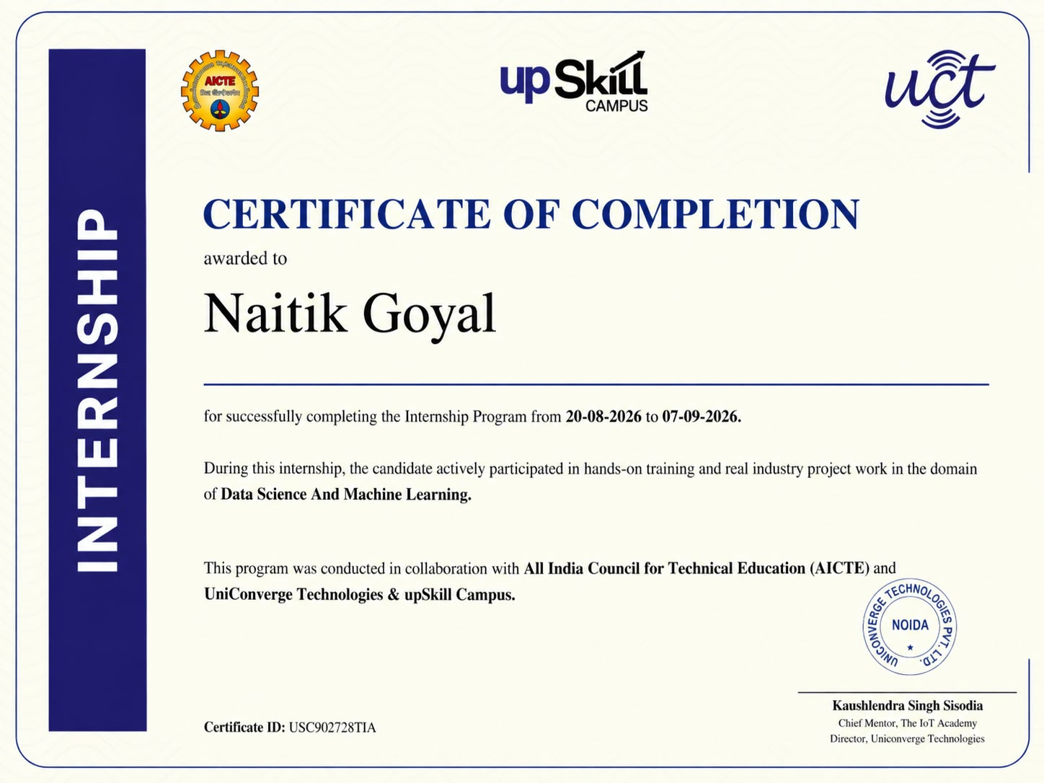

4. PROJECT DESCRIPTION

4.1 Introduction
The internship focused on applying data science concepts to practical prediction and forecasting problems. Two projects were considered: Agriculture Crop Production Prediction and Smart City Traffic Forecasting. The projects provided practical exposure to data preprocessing, exploratory data analysis, feature engineering, machine learning and forecasting.
The work followed a general data science workflow consisting of understanding the problem, preparing data, exploring patterns, developing predictive approaches and evaluating outcomes. The internship also strengthened conceptual knowledge through study of “Introducing Data Science” and practical project activities.

4.2 Organization Profile
USC_TIA is the internship organization associated with this training program. The internship was undertaken in the Data Science domain with an emphasis on practical learning, analytical thinking and project-based application of data science concepts.
Specific organizational information such as official address, registration details, mentor designation and organizational history should be inserted from the official internship documents or certificate where required.

4.3 Problem Statement
Project 1 addresses the challenge of predicting agricultural crop production using historical and relevant agricultural features. Reliable production prediction can support analysis of production trends and help understand the factors associated with crop output.
Project 2 addresses the challenge of forecasting traffic volume in a smart-city environment. Understanding hourly, daily and peak traffic patterns can support data-driven traffic monitoring, planning and congestion management.

4.4 Project Objectives
• To understand and apply the data science workflow to real-world problem domains.
• To preprocess and explore agricultural and traffic-related datasets.
• To identify meaningful patterns and relationships through exploratory data analysis.
• To develop baseline machine learning/forecasting approaches for prediction.
• To evaluate model performance using suitable metrics.
• To improve practical skills in Python, data analysis, visualization and machine learning.

4.5 Scope of the Project
The scope includes data preprocessing, exploratory analysis, feature engineering, model development and evaluation for two application domains. The agriculture project focuses on crop production prediction, while the traffic project focuses on traffic-volume forecasting and peak-period identification.
The projects are intended as internship-level analytical prototypes. Their results can be extended with larger, validated datasets, additional features and more advanced models.

4.6 Technologies and Tools Used
Technology/Tool | Purpose | Application
Python | Programming | Data processing and modelling
Pandas | Data handling | Cleaning and transformation
NumPy | Numerical computing | Numerical operations
Matplotlib | Visualization | Charts and trends
Seaborn | Visualization | Statistical plots and heatmaps
Scikit-learn | Machine Learning | Model training and evaluation
Jupyter/Notebook Environment | Development | Experimentation and analysis
GitHub | Version control/sharing | Project documentation and code management

4.7 System Architecture
The common architecture followed by both projects can be represented as: Data Source → Data Collection → Data Cleaning → Exploratory Data Analysis → Feature Engineering → Model Development → Model Evaluation → Prediction/Forecasting → Visualization and Reporting.
[Figure 4.1: System Architecture – Insert project workflow diagram here.]
The architecture is designed as a sequential data science pipeline in which each stage prepares information for the next stage. The final stage communicates analytical and predictive results through visualizations and performance measures.

4.8 Methodology

4.8.1 Project 1: Agriculture Crop Production Prediction

Problem Statement
The objective is to analyze agricultural production data and develop a predictive approach for estimating crop production. The project emphasizes understanding historical production patterns and identifying useful predictive features.

Data Preprocessing
The preprocessing stage includes checking the dataset structure, handling missing or inconsistent values where required, converting variables into suitable formats, and preparing the data for analysis and modelling.

Exploratory Data Analysis
EDA is used to examine production trends, crop-wise distributions and relationships among numerical variables. Visualizations such as trend plots, distribution charts and correlation heatmaps help identify patterns and potentially useful features.
[Figure 4.2: Agriculture Crop Production Trend – Insert actual plot here.]
This figure shows changes in crop production over the available years and helps identify broad production trends.
[Figure 4.3: Agriculture Correlation Heatmap – Insert actual plot here.]
This heatmap summarizes relationships among numerical variables and supports feature selection and interpretation.

ML Approach
Baseline machine learning models can be trained after preprocessing and feature engineering. Model performance should be compared using metrics such as MAE, RMSE and R², with the final model selected based on the observed evaluation results.
[Table 4.1: Agriculture Dataset Description – Insert actual columns, data types and descriptions.]
[Table 4.2: Agriculture Model Comparison – Insert actual model names and measured MAE, RMSE and R² values.]
[Figure 4.4: Actual vs Predicted Crop Production – Insert actual plot here.]
The plot compares observed production with model predictions and provides a visual assessment of prediction accuracy.
[Figure 4.5: Feature Importance – Insert actual plot here.]
The figure highlights features that contribute most strongly to the selected prediction model.

4.8.2 Project 2: Smart City Traffic Forecasting

Problem Statement
The project focuses on predicting traffic volume over time and identifying periods of higher traffic intensity. Where a real traffic dataset is unavailable, a synthetic dataset can be designed to represent realistic hourly, daily, weekday/weekend and peak-hour patterns.

Data Cleaning
Traffic data is checked for missing values, duplicate records, incorrect timestamps and inconsistent formats. Timestamp fields are converted into usable date-time variables before analysis.

EDA
Exploratory analysis examines traffic variation across time and contextual variables. Five useful visualizations are hourly traffic volume, daily traffic trend, weekday versus weekend traffic, weather versus traffic, and actual versus forecasted traffic.
[Figure 4.6: Hourly Traffic Volume Pattern – Insert actual plot here.]
Shows traffic volume at different hours and helps identify recurring peak periods.
[Figure 4.7: Daily Traffic Trend – Insert actual plot here.]
Shows how traffic volume varies across different days.
[Figure 4.8: Weekday vs Weekend Traffic – Insert actual plot here.]
Compares traffic behaviour between weekdays and weekends.
[Figure 4.9: Weather vs Traffic – Insert actual plot here.]
Shows the relationship between weather conditions and traffic volume.
[Figure 4.10: Actual vs Forecasted Traffic – Insert actual plot here.]
Compares observed traffic volume with the forecasting model output.

Feature Engineering
Time-based features such as hour, day, weekday/weekend indicator, month and peak-hour indicator can be derived from timestamps. These features help models capture recurring temporal patterns.
[Table 4.3: Traffic Dataset Description – Insert actual variables and descriptions.]
[Table 4.4: Synthetic Traffic Dataset Sample – Insert representative records.]
[Table 4.5: Feature Engineering Summary – Insert created features and their meanings.]

Modeling and Evaluation
Suitable machine learning or time-series forecasting approaches can be trained using the engineered features. Evaluation should be based on appropriate error metrics such as MAE and RMSE, with model comparisons documented using actual experimental values.
[Table 4.6: Traffic Forecasting Model Comparison – Insert actual model metrics.]

Forecasting and Peak Prediction
The forecasting stage generates expected traffic volumes for future or held-out time periods. Peak prediction identifies periods where predicted traffic is comparatively high, which can support planning and traffic-management decisions.
[Figure 4.11: Peak Traffic Prediction – Insert actual plot here.]

4.9 Expected Outcomes
• A structured understanding of the data science workflow.
• Cleaned and analyzed datasets suitable for modelling.
• Meaningful visual insights into agricultural and traffic patterns.
• Baseline predictive and forecasting models with documented evaluation.
• Improved ability to interpret model outputs and communicate analytical findings.
• Practical readiness for further work in Data Science and Machine Learning.

4.10 Certificates of Completion and Communication Mail Proof
The internship completion certificate and relevant communication/e-mail proof must be attached in this section. The original documents should be inserted after this page or placed in the appendix, according to the college submission requirements.
[Certificate Attachment Placeholder]
[Communication E-mail Screenshot Placeholder]

4.11 Week-wise Internship Progress
Week 1: Onboarding, environment setup, understanding the internship workflow and initial data work.
Week 2: Study of “Introducing Data Science” to strengthen conceptual foundations in data science and analytics.
Week 3: Deeper exploratory data analysis and logical continuation into feature engineering for project datasets.
Week 4: Baseline machine learning models, initial results, model comparison and feature-importance analysis.

4.12 Challenges and Learnings
Key challenges included understanding dataset structure, selecting useful features, maintaining data quality and translating domain requirements into measurable analytical tasks. The internship improved practical understanding of preprocessing, EDA, visualization, machine learning and forecasting.
Working across agriculture and smart-city traffic domains also strengthened domain adaptability. It demonstrated that the same data science workflow can be adapted to different problem statements by changing the features, evaluation approach and modelling strategy.

4.13 Future Work
Future improvements may include collecting larger and more reliable datasets, incorporating additional domain-specific features, testing advanced machine learning and time-series models, tuning hyperparameters, performing stronger validation and deploying models through user-facing applications or dashboards.

5. BIBLIOGRAPHY / REFERENCES
“Introducing Data Science” – internship study/reference material.
Upskill campus internship learning material and project guidance documents.
Government agricultural datasets and related public data resources, where applicable.
Kaggle traffic-data schemas and publicly available traffic forecasting datasets, where applicable.
Python, Pandas, NumPy, Matplotlib, Seaborn and Scikit-learn documentation used for implementation and learning.

